Discovery covenant domaingroup ldap search request:

Since case is related to ldap, start the search with ldap keyword.
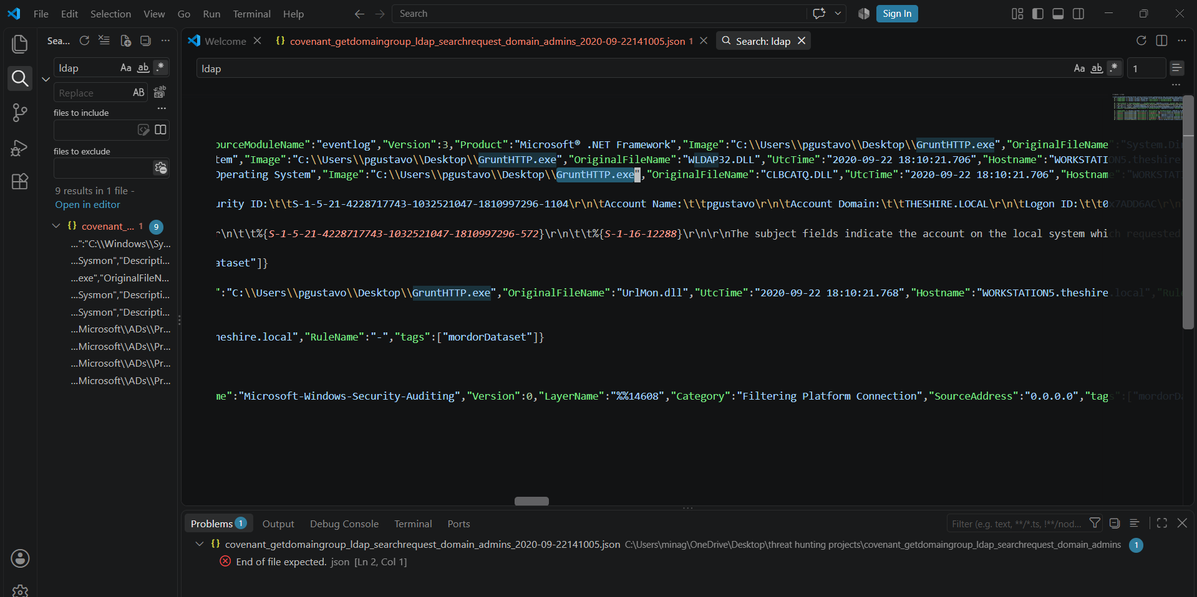

The process started with the executable name GruntHTTP.exe and files target for ldap discovery are are theshire.local.sch

The Windows Filtering Platform has permitted a connection.\r\n\r\nApplication Information:\r\n\tProcess ID:\t\t3112\r\n\tApplication Name:\t\\device\\harddiskvolume2\\users\\pgustavo\\desktop\\grunthttp.exe\r\n\r\nNetwork Information:\r\n\tDirection:\t\tOutbound\r\n\tSource Address:\t\t172.18.39.5\r\n\tSource Port:\t\t62322\r\n\tDestination Address:\t172.18.38.5\r\n\tDestination Port:\t\t389
Source and destination in same class b network and user name is pgustavo
Overall activity:
The activity is related to executable GruntHTTP.exe executes the ldap discovery to collect information about domain controller which is at same domain.

